Project Initialization and Planning Phase

Date | 27 February 2026
Team ID | LTVIP2026TMIDS66231
Project Name | IntelliSQL: Intelligent SQL Querying Using Gemini Pro
Maximum Marks | 3 Marks

Define Problem Statements:

Database users, analysts, and business managers often struggle to extract meaningful insights from databases due to the complexity of SQL syntax and the technical expertise required. Non-technical users face significant barriers when trying to access database information, leading to dependency on technical teams for simple data requests. The lack of AI-powered tools that can translate natural language questions into SQL queries creates inefficiency, frustration, and limits data exploration capabilities across organizations.
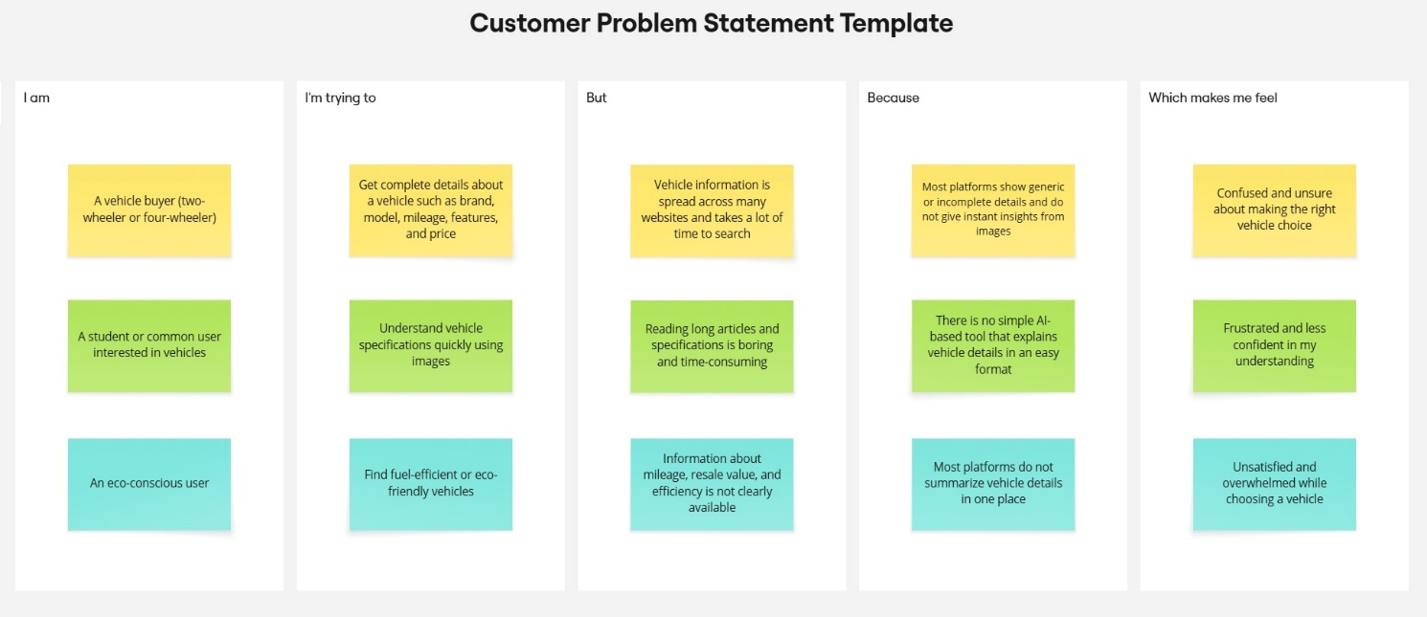

Problem  Statement (PS) | I am  (Customer) | I’m trying to | But | Because | Which makes me feel
PS-1 | A database user or analyst | Write SQL queries to extract specific data from databases | Writing complex SQL queries is time-consuming and error-prone | SQL syntax is complex and I need to remember table structures | Frustrated and slowed down in my work
PS-2 | A business user or manager | Get quick answers from database without learning SQL | I don't know SQL syntax and database structure | There's no simple way to ask questions in natural language | Dependent on technical team members for simple data requests
PS-3 | A non-technical user | Understand and explore database content easily | Current tools require technical knowledge I don't have | No AI-powered tools translate my questions to SQL queries | Limited and unable to explore data independently

